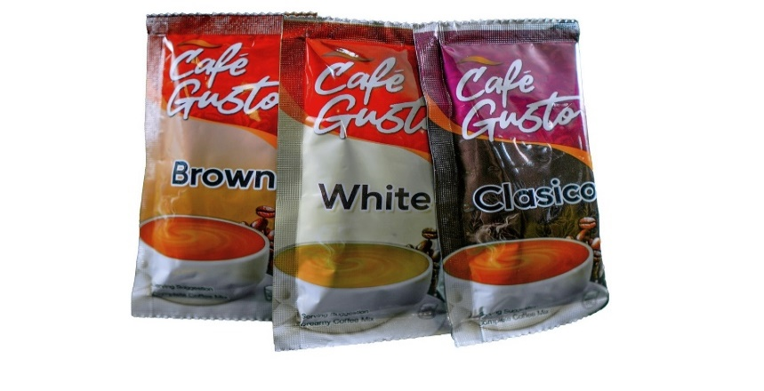

March 22, 2023

Mr. Chito Firmacion,

Greetings!

We are TMT Foods, Inc., a manufacturing company based in Cavite that produces a premium-tasting 3-in-1 coffee mix.

We would like to introduce our products which we believe will be mutually beneficial to both our organizations:

|  |  |  |  |  |  |  |  |
| --- | --- | --- | --- | --- | --- | --- | --- |
| **SKU** | **SKU PACKING** | **LIST PRICE (VAT Inclusive)** | | **SRP** | | Piece  Code | Case  Code |
| **BOX** | **PIECE** | **BOX** | **PIECE** |
| Café Gusto 3-in-1 Premium Taste Coffee Mix (Clasico) | 1x27 grams | 1,800.00 | 10.00 | 1,890.00 | 10.50 |  |  |
| Café Gusto 3-in-1 Premium Taste Coffee Mix (Brown) | 1x27 grams | 1,800.00 | 10.00 | 1,890.00 | 10.50 |  |  |
| Café Gusto 3-in-1 Premium Taste Coffee Mix (White) | 1x28 grams | 1,800.00 | 10.00 | 1,890.00 | 10.50 |  |  |

**Café Gusto 3-in-1 Premium Taste Coffee (Clasico) –** Immerse yourself in the rich, classic coffee flavor of Clasico. This blend strikes the perfect harmony between sweetness and creaminess, creating a delightful and robust coffee indulgence.

**Café Gusto 3-in-1 Premium Taste Coffee (Brown) –** Dive into the exquisite taste of our Brown coffee powder mix characterized by a caramel-like sweetness that expertly counterbalances the robust coffee notes. This blend offers a harmonious fusion of sweetness and coffee depth.

**Café Gusto 3-in-1 Premium Taste Coffee (White) –** For those seeking a velvety coffee experience, our White coffee powder mix delivers a creamy blend that beautifully complements the bold coffee essence without overwhelming it. It’s the perfect balance of coffee and creaminess.

Please feel free to contact your assigned authorized TMT Foods, Inc. representative for your orders and queries.

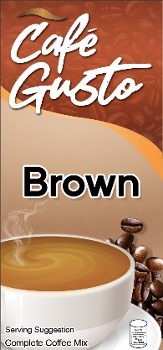We are ready to grow your business with you!

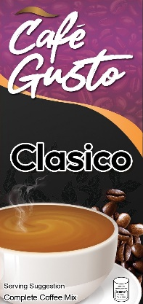

Sincerely,



Nelson L. Lu  
Sales and Marketing Head  
TMT Foods, Inc.